**Author Portfolia Website Assignment**

Step1: Create a experience fragment for header.

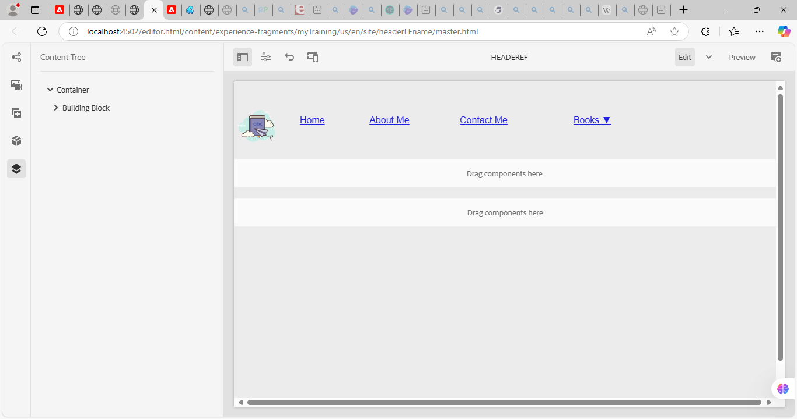

Step2: Similarly create a experience fragment for the footer.

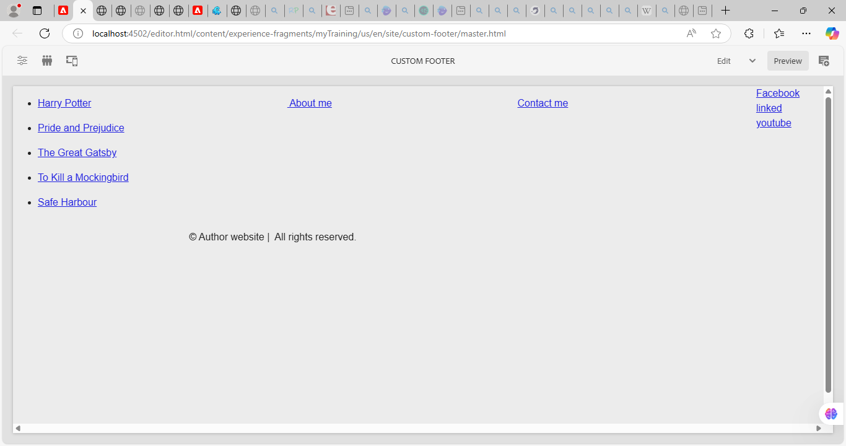

Step3: Now add them to the template .

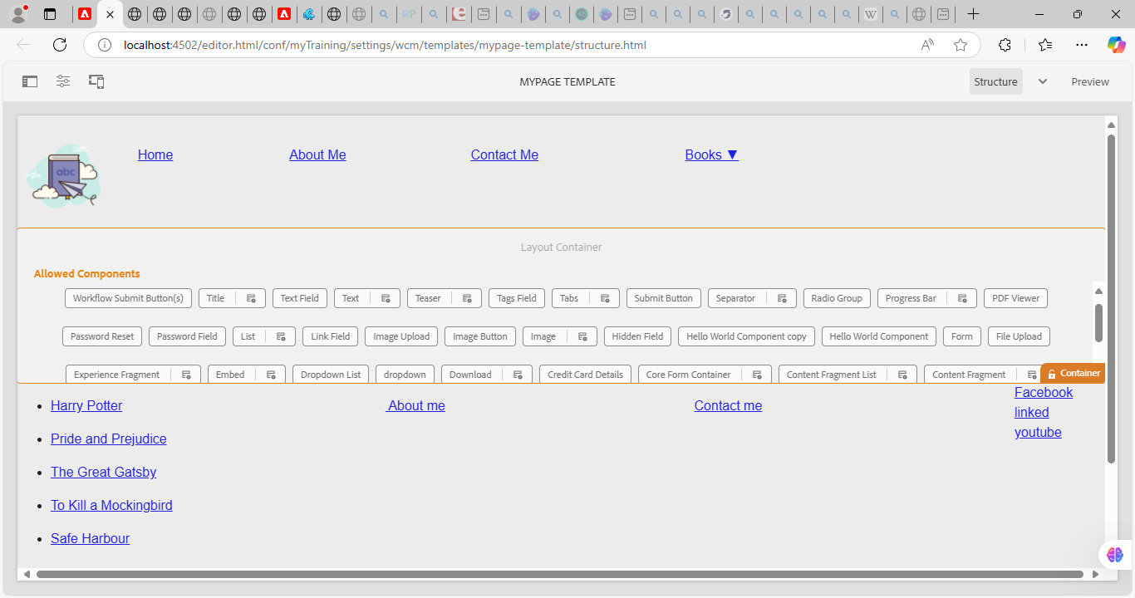

Step 4: Now create a Home page using this as a base template. It display some award ceremony for author.

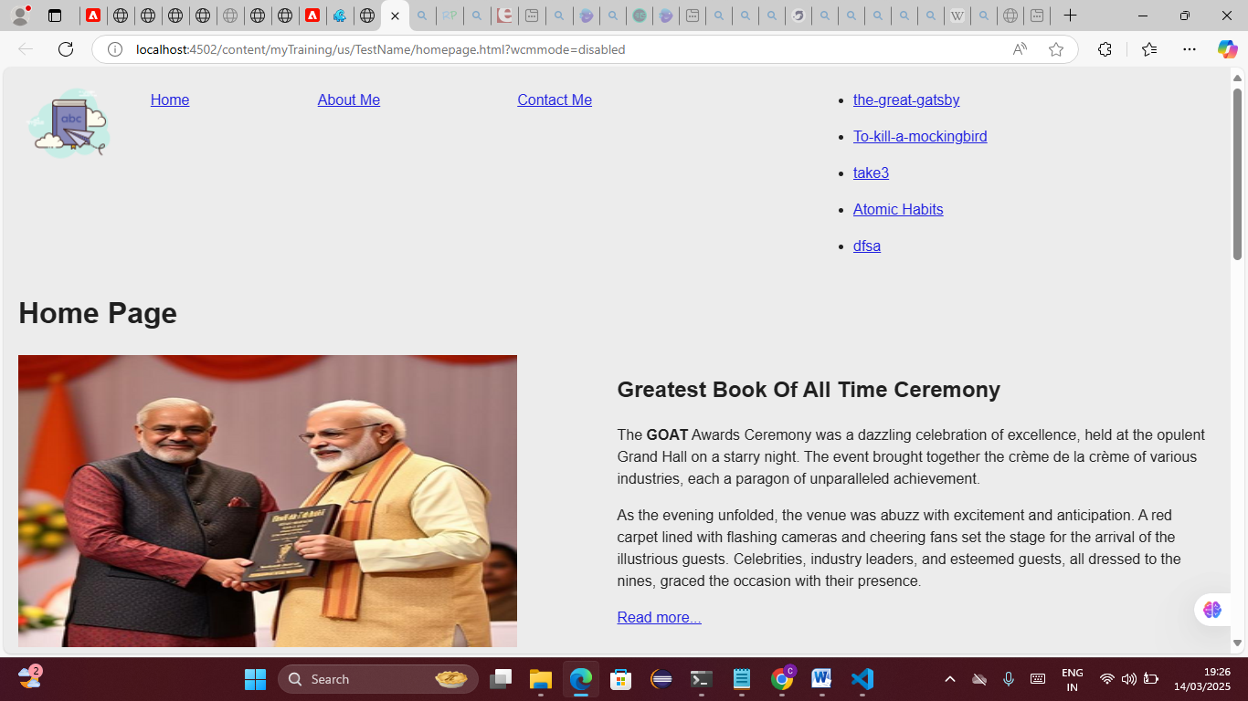

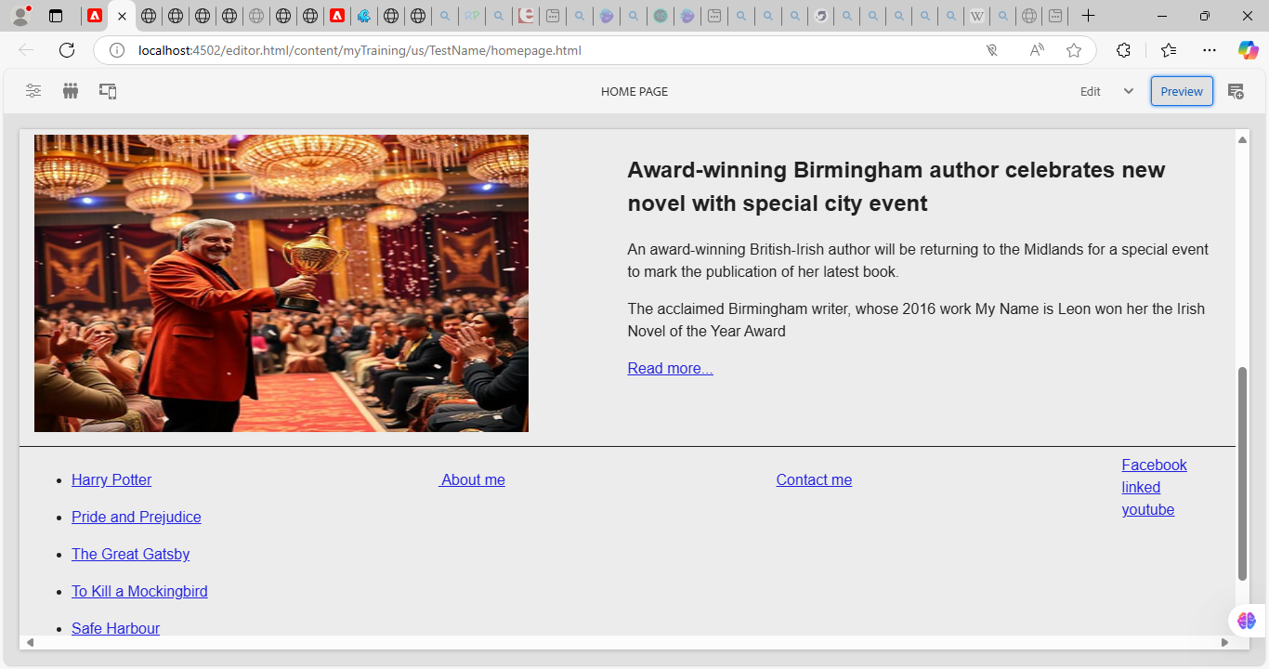

Step 5: When you click on read more . it takes you to the about me page.

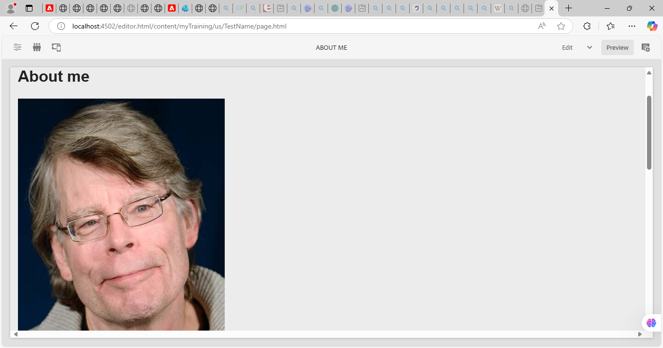

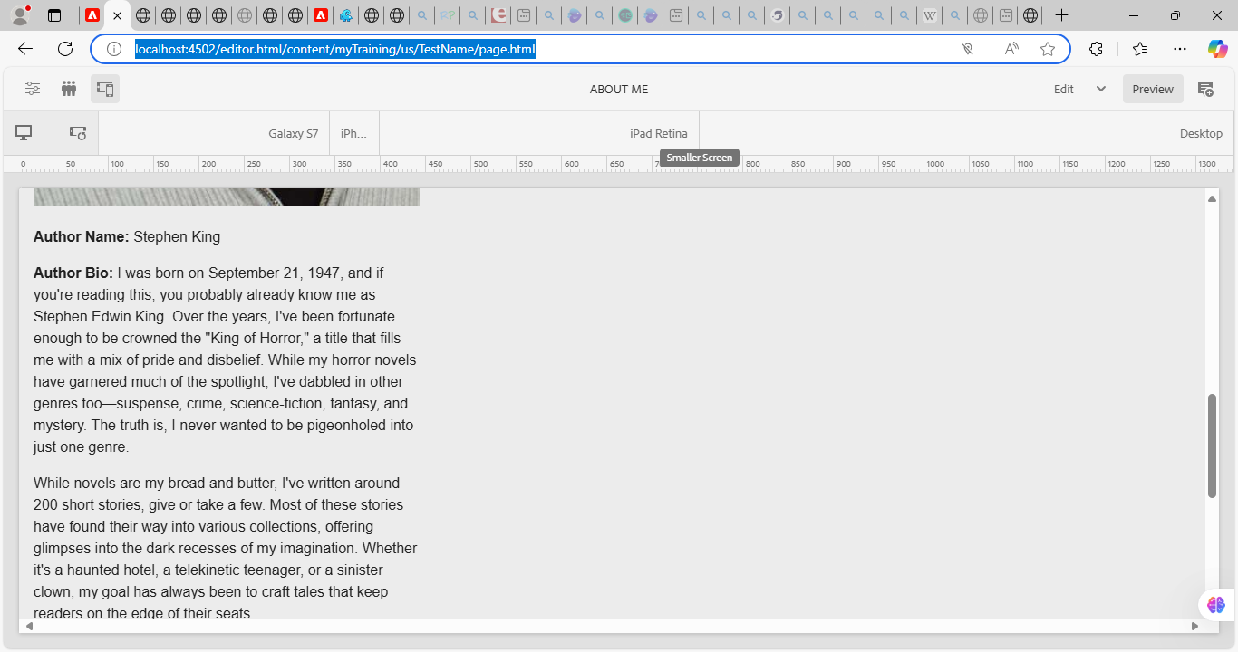

Step 6: next create a contact me page.

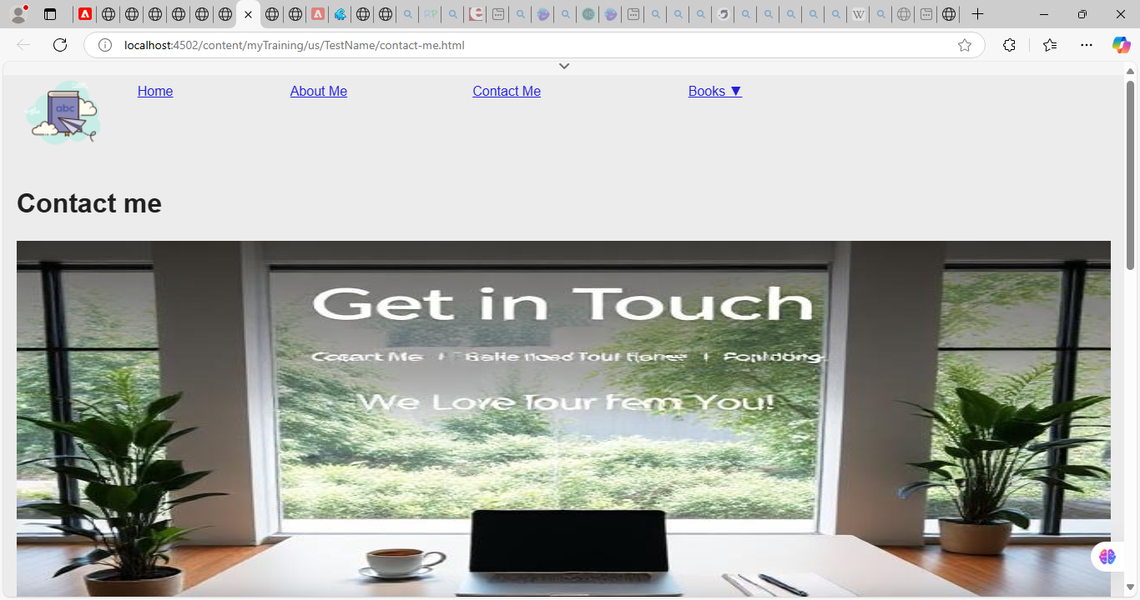

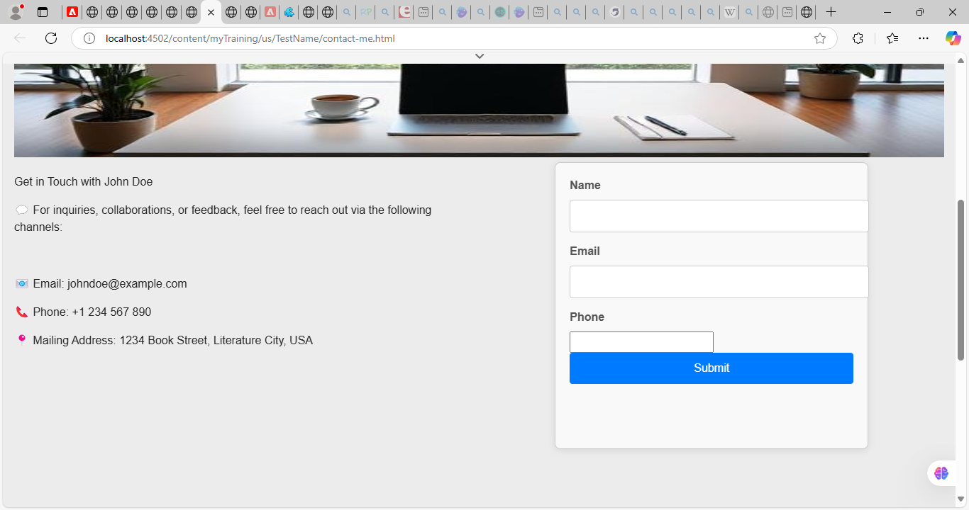

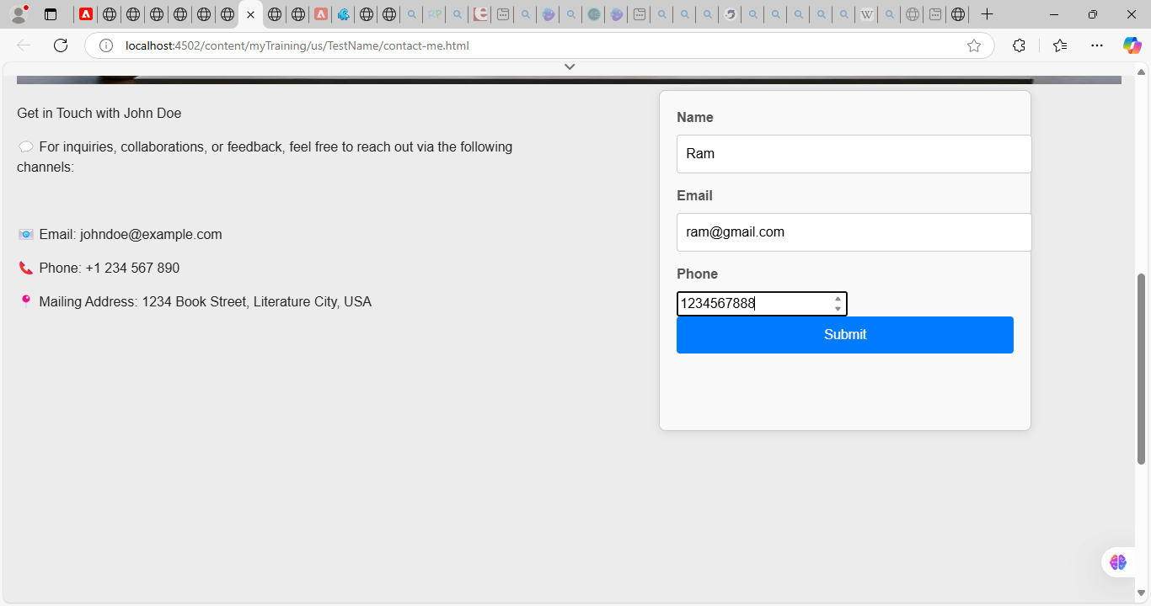

Step 7: Header displays books as dropdown.

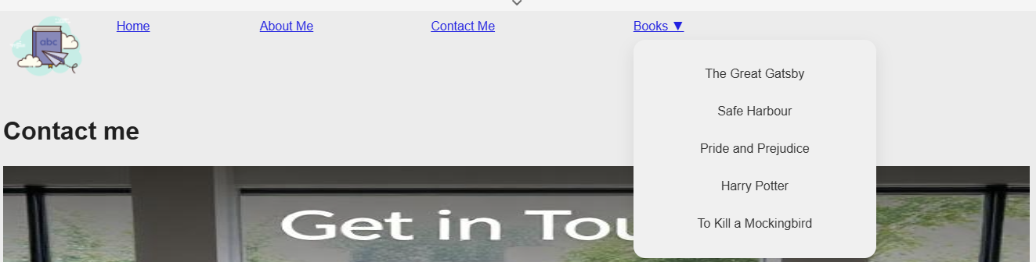

Step 8: Footer has social media links .when clicked it takes to respective page.

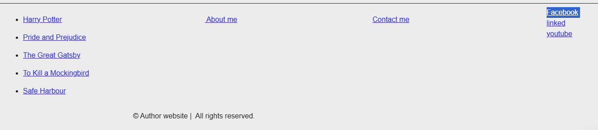

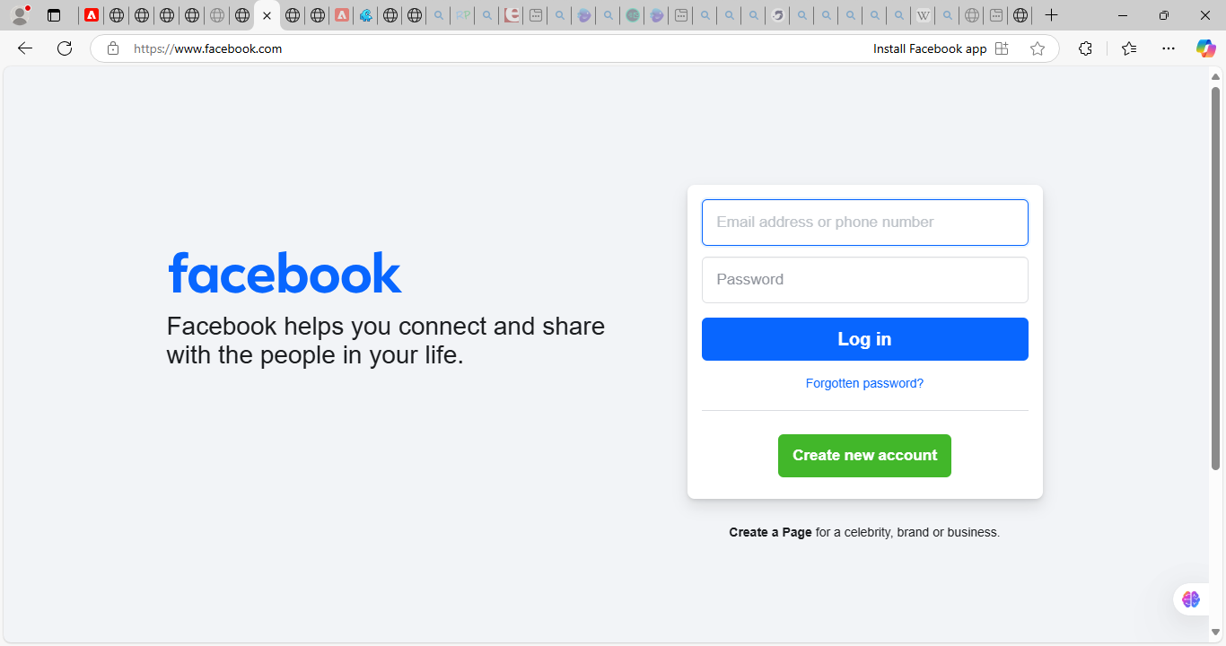

Step 9: Create a Books page which list all the books.

